Dear Parents,
My name is Ms. Cynthia Saavedra and I am your child’s kindergarten teacher at Dan H. Roosevelt Elementary School. I am happy to have your child in my classroom.
Welcome!

I believe that teachers and parents should work together in order to help the student succeed. It’s also important for you to know a little about me. I graduated from Concordia University Chicago and I spent a year preparing for this school year. I invite you to make a visit, call, or email me if you’d like to hear more about my credential or to discuss your child’s progress.
This year we will be covering many subjects like colors, spelling, numbers, seasons, and dates just to name a few! Your child will start making many new and different friends. It’s very important that you talk to your child about what they learn because it is at this age that they love to talk. With your help this year will be the best year!
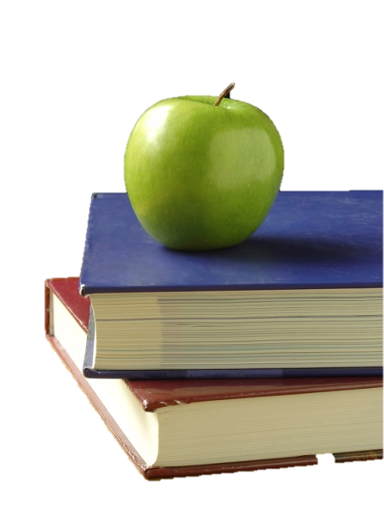
Don’t forget; feel free to contact me with any further questions!

Sincerely,
Cynthia Saavedra
708-555-1234 or SaavedraC@D88.org

